BREAST RECONSTRUCTION
Whether you’ve already made the decision to undergo breast reconstruction, or you’re just looking for more information about the procedure, this eBook can help: it follows the same format as a discussion you might have with your doctor in the office and answers common questions we hear from our patients.
The general topics that we cover in this book are:
- A brief history of breast reconstruction.
- Why breast reconstruction is important —it’s so much more than a simple cosmetic consideration.
- Options for using tissue from your own body for breast reconstruction.
- An organized system for understanding implant-based reconstruction with the overlap of reconstruction that uses your own tissue.
- How to improve on a completed breast reconstruction for optimal results.
- Nipple and areola reconstruction options.
- Commonly asked questions about breast reconstruction and surgery in general.

A BRIEF HISTORY OF BREAST RECONSTRUCTION
Breast reconstruction has undergone a significant evolution over the last few decades. Originally, the procedure was developed out of the need to correct a deformity resulting from a mastectomy. Undergoing reconstruction was a lengthy process — even meeting with a surgeon historically took one full calendar year after successful breast cancer treatment, which usually included a mastectomy, chemotherapy and even possibly radiation. However, we now know that reconstruction is definitely much more complicated after the body has healed and scarred in and possibly been even further affected by radiation.

Therefore, this delayed reconstruction approach soon evolved into immediate breast reconstruction—reconstruction performed at the time of mastectomy—which allowed the plastic surgeon to work within an area that was not yet healed over, scarred in and contracted.

However, meeting a plastic surgeon to discuss options for breast reconstruction may be the last thing on some patients’ minds in the wake of a new breast-cancer diagnosis. We wrote this eBook with that in mind, because we want every patient to have these resources easily available. We also hope that we can provide answers to most questions that are commonly asked by patients with a newly diagnosed breast cancer.

Why Breast Reconstruction Matters
There is pretty good scientific evidence to support having breast reconstruction as opposed to undergoing mastectomy alone.

- Better body image.
- Improved spinal alignment, posture and physical function.

Reduced risk of lymphedema (arm swelling).
- Better sexual function.
- Fewer depressive symptoms.
- Better breast symmetry.
- Better breast aesthetics.
- Improved lymphedema in patients with delayed reconstruction.

AUTOLOGOUS BREAST RECONSTRUCTION or, in simple words, REARRANGING YOUR OWN BODY FOR BREAST RECONSTRUCTION

As recently as a few years ago, we plastic surgeons would routinely recommend rearranging your body in order to “create” a breast for breast reconstruction. Using a portion of your tummy (abdominal) area, known as the TRAM (Transverse Rectus Abdominis Myocutaneous) flap, or a back muscle called a Latissismus dorsi (aka “Lat Flap”) was the state-of-the-art way to reconstruct a breast.

The TRAM flap involves rearranging or transplanting your abdominal skin, fat and muscle in order to reconstruct your breast. The TRAM flap can be rotated into place or actually transplanted into place using a procedure known as free-tissue transfer. When the TRAM flap is created with a muscle-sparing technique and transplanted into place, the procedure is called a DIEP flap.
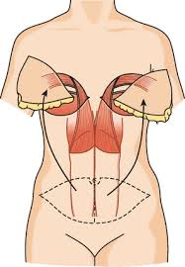

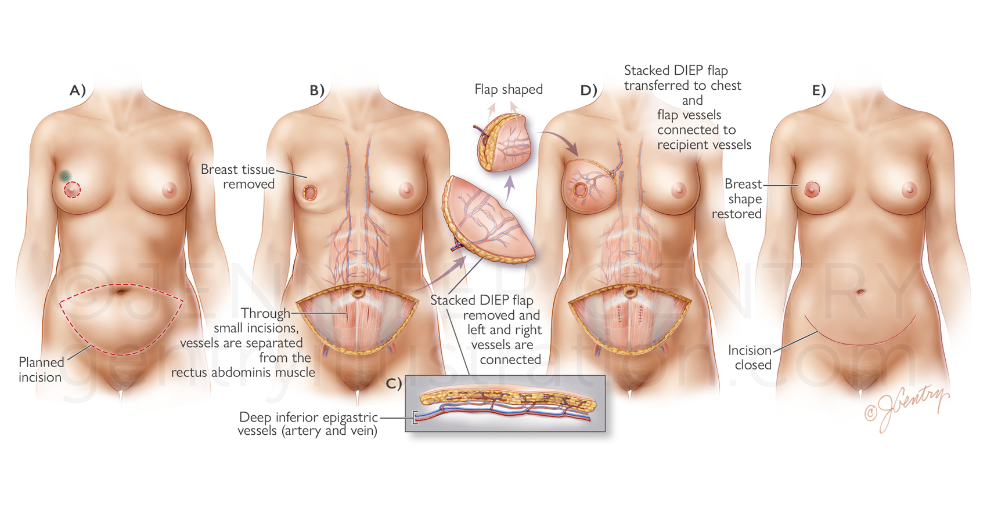

The “Lat flap” is created from an expendable muscle from your back area, the Latissimus dorsi muscle, along with the overlying skin and fat, to rotate into the breast area, in order to replace the skin over the chest or breast area.

Once the Lat flap is rotated into position, an adjustable implant called a tissue expander (TE) can be placed under the Lat implant during the same procedure. After a few weeks, the Tissue Expanding implant can then be adjusted to resize the reconstruction to better match the breast on the other side.
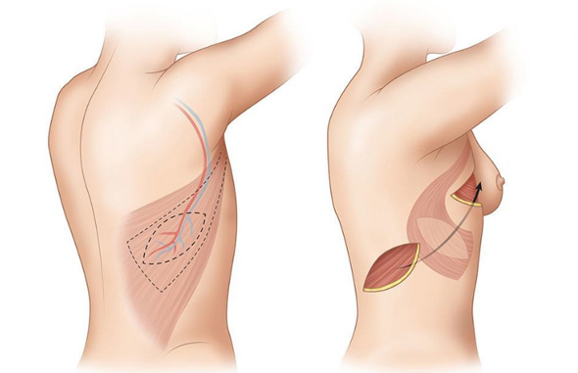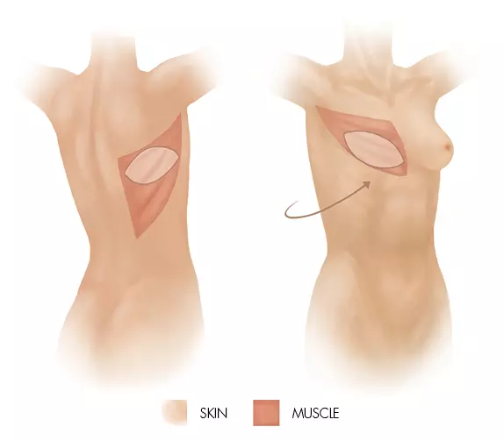

Both of these “flap” surgeries borrow tissue from one area of your body and replace the breast tissue that was removed through your mastectomy. Although these procedures are very effective, there’s no getting around the fact that you are borrowing one part of the body to reconstruct another, which leaves you with two areas to heal. The surgery is also a little more involved than implant-based breast reconstruction and takes longer to recover from as well.

Oncoplastic Breast Rearrangement Surgery

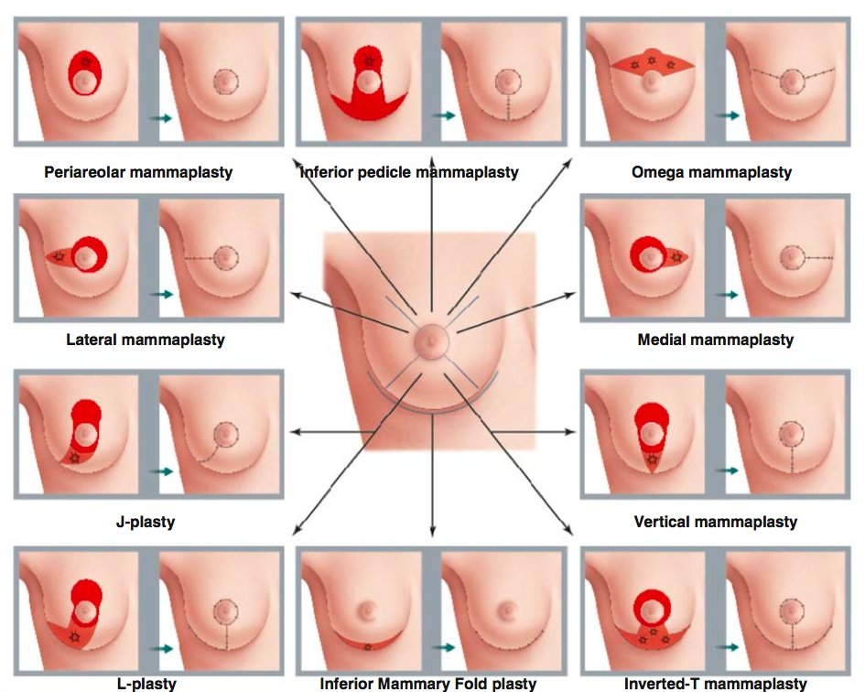
In some situations, it is possible to use your own breast tissue for breast reconstruction. In these cases, either ideally the breast is large enough to allow adequate coverage, or the defect that is left after the breast lump is removed is small enough that remaining breast tissue can be rearranged to fill in the area. A Biozorb device, pictured below, can help keep the space open and breast tissue can be rearranged to cover the area.
For patients who need a breast lift or breast reduction, the tumor can be removed within a pattern that removes that part of the breast and allows the remaining breast tissue to be rearranged by the surgeon during closure into an anatomically more ideal shape and size.
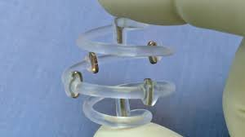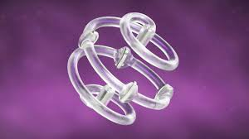

When the procedure is performed in the pattern of breast-reduction surgery, the technique is called an Oncoplastic Breast Reduction. For the patient who has breast cancer within a larger breast, surgery can be designed to remove the cancer (or diseased breast tissue) as part of the breast reduction itself.
The breast tissue that remains after the diseased tissue is removed is then reconstructed in the standard method to create a smaller breast in breast reduction surgery. 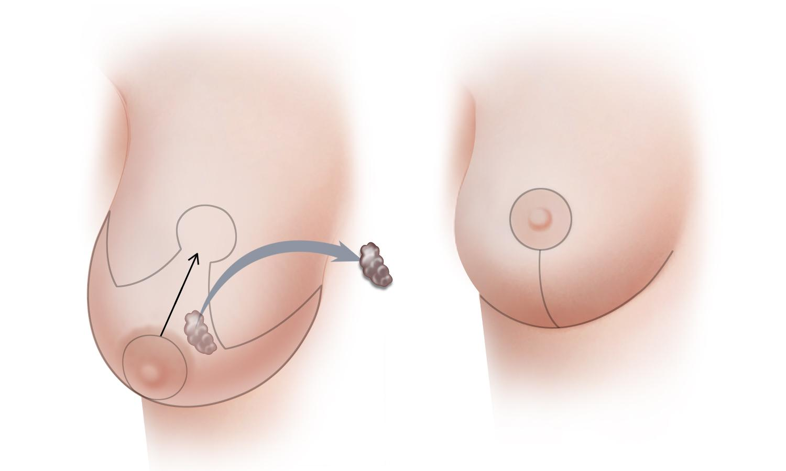
As a quick review, using the remaining breast tissue within a breast-reduction pattern is called Oncoplastic Breast Reduction. Oncoplastic Breast Reduction requires careful planning with the Breast Cancer Surgeon (aka Surgical Oncologist). Because this technique is usually performed with scheduled radiation to the affected breast, close communication is required between the Breast Cancer Surgeon and the Plastic Surgeon to obtain optimal results. The radiation is typically administered about six (6) weeks after the Oncoplastic breast-reduction surgery, when the patient has healed. Radiation usually shrinks and elevates a breast, so it is important to plan for those expected changes.
If needed, a subsequent mastectomy can be performed after Oncoplastic Breast Reduction surgery. As early as six (6) weeks after an Oncoplastic Breast Reduction, it is possible to receive a completion mastectomy and reconstruction with one of the plans described in the implant-based breast-reconstruction section.
The diagram below shows various patterns for Oncoplastic Breast Reduction for various locations of tumors within the breast.
For patients who need a mastectomy even after having an Oncoplastic Breast Reduction initially, please read ahead to section Plan G.

IMPLANT-BASED BREAST RECONSTRUCTION
Significant improvements in breast-implant technology and surgical techniques now allow breast reconstruction to be performed without rearranging patients’ bodies, thereby minimizing donor site issues and saving hours of operative time. With these advances, implant-based reconstruction surgery is now the most common approach to breast reconstruction throughout the world.

Below is a brief overview of different breast reconstruction options.

PLAN A: Prepectoral Tissue Expander Reconstruction (TE/ADM)
Breast reconstruction on top of the chest muscle called the pectoralis is known as Prepectoral Breast Reconstruction. Prepectoral breast reconstruction is a relatively new technique and currently is considered state of the art.
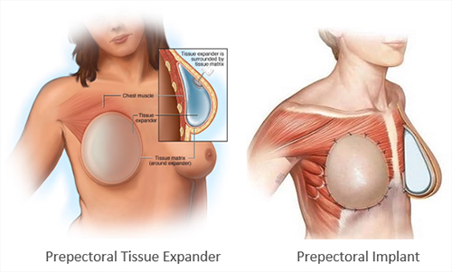
Plan A TE/ADM reconstruction is a two-stage reconstruction approach, meaning it requires two (2) surgeries staged a few months apart to obtain the final result. This approach offers so many advantages over other techniques that it is known as Plan A.

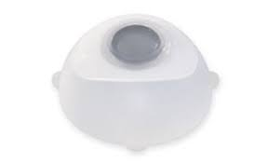
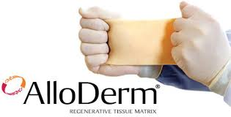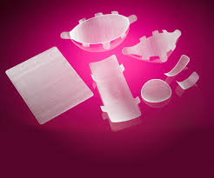
A Tissue Expander (TE) is an implant that can be adjusted after surgery, which allows patients to have the implant expanded to the desired size. A mesh material called an Acellular Dermal Matrix (ADM) provides additional support to hold the Tissue Expander in place on top of the pectoralis muscle that lies anatomically directly below the breast.
The technique of Tissue Expander Prepectoral reconstruction involves inserting, at the time of your mastectomy (breast removal surgery), a postoperatively adjustable implant on top of the chest muscle (prepectoral position) with a variable amount of fluid or air within the implant. The Tissue Expander is secured to the pectoralis muscle that lies just below the breast, using the tabs on the expander and a scaffold of mesh to help secure its position.
After a calculated healing period, the Tissue Expander is then additionally filled with air or fluid week by week until the breast reaches the desired size; the larger the breast the patient wants to achieve, the more weekly fills are required. When radiation is needed, the air-filled tissue expanders are completely deflated and the resulting empty volume is filled with fluid. After radiation, more fluid can then be added week by week until the desired size is achieved.
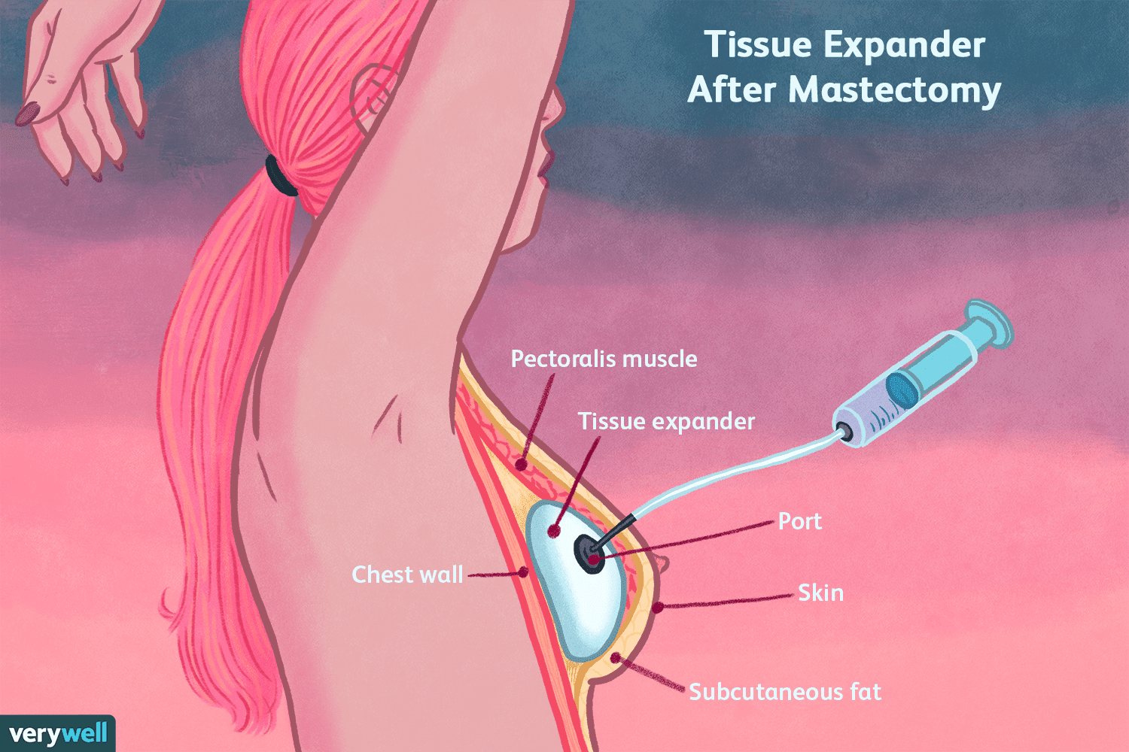
Once the implant reaches the desired size, the stretched skin is held out to size for 4-6 weeks and a second surgery is then planned to replace the Tissue Expanding implant with a permanent cohesive silicone implant of the desired size and shape.
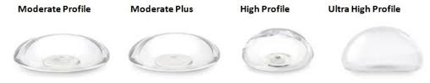
During the exchange surgery, numerous adjustments can be made to optimize the final outcome.

For those of you that need more detail, please keep reading! If you feel like that was enough, skip ahead to Plan B. The next few paragraphs are some more information about Plan A: Prectoral TE/ADM.
Because breast tissue naturally lies on top of the muscle, prepectoral breast reconstruction produces a very natural appearance. Another advantage of the prepectoral technique is that it is more comfortable immediately after surgery because the underlying pectoral muscle is left in place. This allows some patients to go home directly after surgery. Furthermore, the technique preserves normal movement of the muscle, which makes it an ideal approach for athletes and very active women. Finally, the normal motion the pectoral muscle exerts on a breast implant under the muscle is completely avoided, thereby eliminating the common complaints of breast “animation” and implant malposition over time that we see with implant surgery under the pectoralis muscle of the chest.
A final advantage of the prepectoral TE/ADM technique is the ability to position the nipple and areola into a better position if needed. The skin laxity that exists after the breast tissue is removed during mastectomy allows some mobility of the whole nipple and areola complex. If there is excessive skin after the optimal implant is decided upon, skin reduction can be considered during prepectoral tissue-expander reconstruction.
In summary, prepectoral reconstruction of the breast has the following advantages:
- The natural position of breast tissue is on top of the muscle.
- No muscle disruption.
- Less discomfort at the time of surgery.
- Normal muscle activity is preserved.
- No breast “animation” of the reconstruction.
- No long-term risk of muscle-induced implant malposition.
- Allows nipple areola position adjustment during the procedure.
The second-stage surgery for Plan A: TE/ADM takes place a few months later. Although this option does require a second surgery, it offers some clear upsides, which we’ll cover in greater detail shortly.
The second stage involves removing the tissue expander and replacing it with the size and shape implant of the patient’s preference while adjusting any issues, such as position, that may have arisen after healing from the mastectomy or radiation.
This second surgery can be combined with targeted fat grafting. Fat grafting during the second-stage procedure creates a hybrid of implant and fat and offers significant benefits to the reconstruction:
- Blends the breast implant to the chest area.
- Offers shape adjustments when needed.
- Offers volume to the reconstruction without inserting a larger implant.
- Adds insulation to cover the implant to give the final reconstruction a more natural feeling.
The Prepectoral TE/ADM technique (Tissue Expander and Acellular Dermal Matrix) approach is a good option for most patients, particularly:
- The patient who wants to be in control of the ultimate size of their breasts.
- The patient whose circulation does not support the desired size implant.
- The patient with uneven breasts.
- The patient with slightly droopy breasts.
- The patient with prior radiation to the chest area.
- Athletic patients that prefer to have their chest muscle left undisturbed.

PLAN B: Direct to Implant (DTI) Prepectoral Breast Reconstruction (DTI/ADM)
This could be the preferred approach for breast reconstruction when everything is ideal. It achieves a pleasing reconstruction outcome at the time of your mastectomy.
The Direct to Implant (DTI) technique uses a Cohesive (Gummy Bear) Silicone Breast implant to replace breast tissue and places the reconstruction on top of the chest muscle.
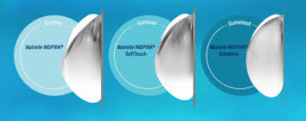
Just to review, when the reconstruction is on top of the muscle, it is called the prepectoral position. The implant is held in place on top of the pectoral muscle with a scaffold that later incorporates itself into your body during the healing phase after surgery. That scaffold can be made from numerous sources, with the most-common being Acellular Dermal Matrix (or ADM). As mentioned above with Plan A, mastectomy removes the breast tissue, allowing the skin of the breast to be mobile. This mobility allows the nipple and areola complex to be moved and secured to an improved position during the reconstruction. The procedure can be abbreviated as DTI/ADM (Direct To Implant reconstruction using an Acellular Dermal Matrix).
Due to many of the variables that can arise during breast-cancer surgery, combined with the lack of anatomically shaped, smooth breast implants, DTI/ADM direct-to-implant reconstruction is no longer the most common approach used for most patients, hence it is known as Plan B. However, DTI/ADM certainly is a good option for certain patients.
The direct-to-implant breast reconstruction surgery (DTI/ADM) is planned with the goal of recreating a breast that closely fills the space left immediately after the mastectomy (breast removal). Prior to surgery, the patient’s breast is carefully measured, so that during the surgery sizing implants can be used with those measurements in mind. Because the breast skin is delicate after the breast tissue is removed, a check of the circulation (aka perfusion) of the breast skin area is performed, first without and then again with, the carefully chosen sizing implant. Occasionally, a smaller implant is inserted if, after the mastectomy, the circulation of the patient’s skin does not support the “bioidentical” size selected. A larger sizing implant can also be tried; if the circulation in the skin flaps after mastectomy supports the larger implant, then the larger implant can be used.
If there is excessive skin after the optimal implant is decided upon, skin reduction can be considered during direct-to-implant reconstruction.
As appealing as single-stage breast reconstruction surgery may be, direct-to-implant reconstruction has limitations and remains a “Plan B” at this time. The limitations of DTI/ADM are summarized as follows:
- Lack of anatomically shaped, smooth breast implants.
- Lack of patient control of implant size and shape.
- Decision of size and shape of the implant is frequently limited by perfusion of the skin after mastectomy.
- Position of the implant can settle during healing into a position that is not ideal.
- Visibility of the implant with visible edges and contours of the implant.
- Visible rippling associated with most implants currently available for breast reconstruction.
- High risk of revisionary surgery for adjustment implant position or size.
- High risk of revisionary surgery to address visible rippling or visibility of implant contours associated with thin tissue after mastectomy.

PLAN C: Submuscular Tissue Expander Reconstruction
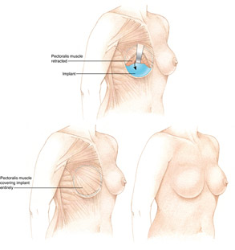
The submuscular placement of a Tissue Expander is a very reliable reconstruction method, commonly used throughout the world. Total submuscular reconstruction does not require a scaffold (aka ADM or Acellular Dermal Matrix) to hold the expander in place. Partial coverage of the reconstruction with muscle is also an option. A scaffold can then be used to hold the implant in place and keep the muscle in position during healing.
. 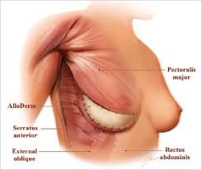

Currently, the submuscular reconstruction technique (with or without an ADM sling) is reserved for specific situations:
- Breast cancer is located very close to the chest muscle.
- Very thin patients.
- Very small-breasted patients.
- Compromised circulation to the skin after mastectomy (breast removal).
- Patients with prior submuscular breast implant augmentation.
The first situation is for the patient who has a breast cancer that is very close to or involves the pectoral muscle of the chest area behind the breast. Because breast cancer can recur locally, regular exams are performed in the office to monitor for cancer recurrence and a reconstruction on top of the muscle would make those exams difficult. Therefore, submuscular placement of the reconstruction is the best option for breast reconstruction when the tumor is close to the muscle.
The second situation is for the patient who is extremely thin. For these patients, the muscle layer helps cover up the implant and minimizes visibility, palpability and rippling. Visibility is the ability to see the implant. Palpability is the ability to feel the implant while “rippling” refers to the change in appearance of the contour of all implants when standing or leaning forward.
The third situation is for very small-breasted patients. This technique allows the breast skin and the pectoralis muscle to be safely expanded together. When the final breast implant is inserted, it is customized to the patient’s personal preference.

The fourth situation is for patients whose skin circulation is not adequate for any prepectoral reconstruction and do not prefer any delay options outlined below. Circulation can be affected by smoking, diabetes and from the actual mastectomy portion of the procedure that removes breast tissue. The option of site conversion to the prepectoral position can be considered at a later time.
The fifth situation listed is for some patients who have prior breast implants under the muscle. A sling of ADM can be used to hold the implant in place after the mastectomy. If during the surgery a sizing implant creates a pleasing outcome, mesh can be used as a sling and a permanent breast implant can be inserted.
Whenever a Tissue Expanding implant is used for reconstruction, a period of healing is planned, followed by weekly addition of fluid to expand the tissues until the desired size is achieved. After allowing the tissues to stretch and hold in that expanded position, a second surgery is then planned within 4-6 weeks to replace the tissue-expanding implant with a permanent breast implant of the desired size.
As previously mentioned, it is a very reliable technique and a very safe option for specific situations. The reasons that this technique is reserved for specific situations is based on a few drawbacks of the submuscular position: breast animation, discomfort and malposition over time.
Breast animation refers to the ability to flex the pectoral muscle, thereby moving the implant. Without breast tissue to cover up the muscle, the movement of the implant with activity or purposeful muscle motion can be seen.
Breast implants behind the muscle are generally well tolerated by cosmetic patients. However, after mastectomy, some patients never feel comfortable with an implant behind the muscle.
Finally, over time, the natural motion of the pectoralis muscle can displace a submuscular implant to a position that is not ideal; this issue is commonly referred to as Implant Malposition. As mentioned before, conversion to the prepectoral position can be considered at a later time (see Plan E, below).
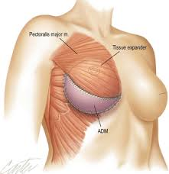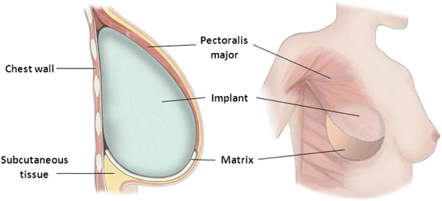

PLAN D: Delay of the Reconstruction
Although rare, circulation to the skin after mastectomy can be compromised or difficult to assess. Thankfully, there are instruments and techniques during surgery that can objectively evaluate the skin’s circulation. A system like the Kent Camera can be used to assess the oxygen level in the skin both before and after the mastectomy. If the circulation to the skin is compromised, delaying the reconstruction by two weeks is definitely an option. In certain centers around the world, delaying or staging a reconstruction is a very common technique.
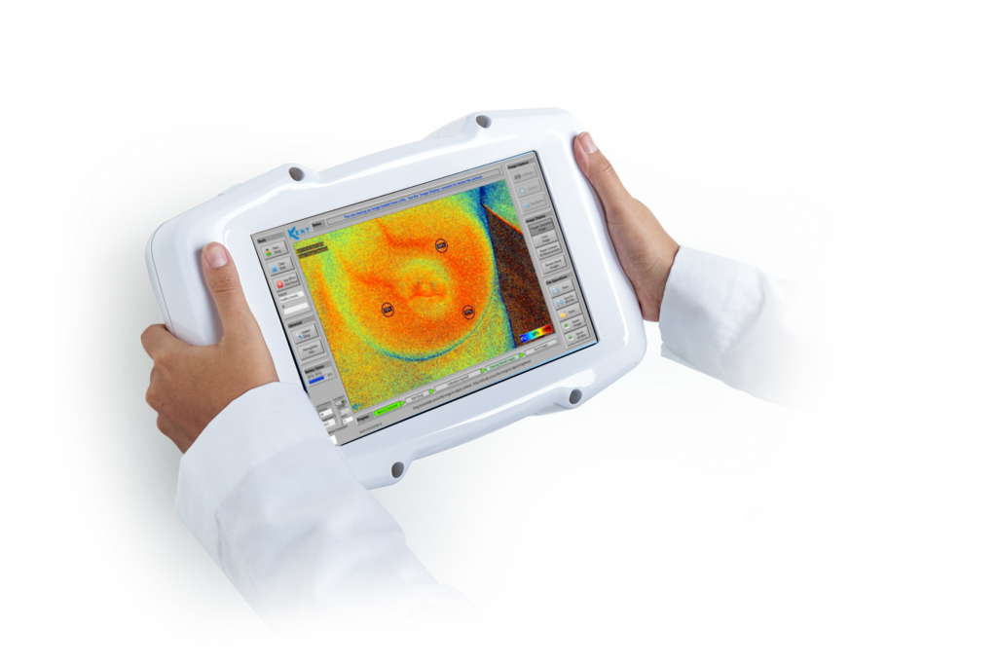
A very safe backup plan to consider is to reserve the option to delay reconstruction by a few weeks. After a mastectomy, the circulation in the skin flaps will have a chance to rebound and strengthen after 10-14 days. As long as the skin is healthy after the delay time, a Plan A: Tissue Expander (TE/ADM) or Plan B: Direct to Implant (DTI/ADM) in the prepectoral space can then be performed safely. This is a great option for patients who smoke or have circulation issues such as diabetes.

Plan E: Exchange of the implant from the submuscular position to the prepectoral position, AKA pocket conversion or “site conversion”
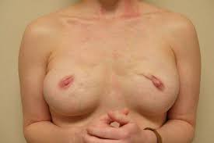
The procedure to convert a reconstruction from under the muscle to the natural position of breast tissue (which is on top of the muscle) can be an option. The surgical procedure involves removing the implant from the top of the muscle and recreating the pocket where the breast tissue was prior to the mastectomy. The muscle is then reattached to the chest area and the pocket measured to determine implant size after which a mesh is inserted and sewn into place. The chosen implant is then inserted under the mesh. It is an outpatient procedure and well tolerated by the patient as all the difficult components, such as expansion, are performed in the prior reconstruction sequence.
Exchange of site is an option for patients with the following conditions:
- Dissatisfaction or discomfort with submuscular reconstruction.
- Recurrent malposition of implant with submuscular reconstruction.
- Circulation or skin flap perfusion issues after mastectomy requiring submuscular reconstruction.
- Uncertain oncologic margins at the time of mastectomy.
Patients that have a breast-implant reconstruction under the muscle (AKA submuscular position) and are not comfortable with the implant or are dissatisfied with the outcome, can consider conversion to the prepectoral position.
For those patients whose skin circulation is not adequate for prepectoral reconstruction, a reliable option is to place a submuscular tissue expander at the time of the mastectomy and then convert to a prepectoral position at the time of exchange to a permanent breast implant.
If the reconstruction was performed under the muscle due to the location of the breast tumor, the surgical oncologist (AKA breast-cancer surgeon) or medical oncologist can guide you as to whether Plan E: Exchange or Site Conversion is an option. Some patients should never convert position, due to the importance of monitoring the area for life. Other patients can be monitored for a few years and then be approved for Plan E: Exchange.
Patients who have had submuscular reconstruction years ago, or whose initial submuscular tissue expander reconstruction for breast cancer was performed by another surgeon, who now hope to convert their reconstruction at the second operation to the prepectoral position, should confirm with their doctors that Plan E (or Exchange/ Site conversion to a prepectoral position) is a safe oncologic option.

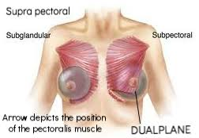

HYBRID IMPLANT AND AUTOLOGOUS TISSUE RECONSTRUCTION
PLAN F: Salvage procedures of breast reconstruction covering an implant
If reconstruction has failed or the effect after radiation therapy is too profound to consider other options, replacing the affected area with unaffected tissue may be considered. The more common options for salvage techniques include the following:
1. Latissimus Dorsi Flap over Tissue Expander: this thin muscle can be harvested from the back, along with skin and fat, and then rotated under the skin to replace the affected tissue of the breast area to cover an expanding implant.
3. TRAM Flap over Implant or Tissue Expander: involves rearranging the abdominal skin, fat and muscle to reconstruct your breast. This area can be used to replace a significant amount of both breast tissue and skin in the breast area. The tissue can either be rotated into the breast area or transplanted completely. Augmentation of the TRAM flap may be done with an implant under the TRAM flap. A Tissue Expander can also be considered.
5. DIEP Flap and implant combination: similar to a TRAM flap, but is a muscle-sparing technique that involves transplantation of the abdominal skin and fat. The combination of DIEP flap with an implant can offer better options in size and shape than DIEP or TRAM flap surgery alone.
PLAN G: Great size and shape before mastectomy
Plan G may sound a little familiar, as it starts as a Oncoplastic Breast Reduction as mentioned above in the “Using Your Body For Reconstruction” section under Oncoplastic Breast Rearrangement. The difference is that after 6-12 weeks, a planned completion mastectomy can be performed on a smaller and perkier breast. So here is a recap of the process:
Step 1. For the patient who has large breasts and also has cancer or diseased tissue in part of the breast, breast-reduction surgery can be designed to remove the cancer as part of the breast reduction. This technique is called Oncoplastic Breast Reduction. It requires careful planning with the breast cancer surgeon (AKA surgical oncologist). Because this technique is performed with planned radiation to the breast, close communication is necessary to obtain optimal results. The radiation is typically administered about six (6) weeks after the surgery when the patient has healed from the breast-reduction surgery. Radiation usually shrinks and elevates a breast, so planning for those expected changes is required.
Step 2. If needed, a subsequent mastectomy can be performed after Oncoplastic Breast Reduction surgery. As early as six (6) weeks from an Oncoplastic Breast Reduction, a completion mastectomy and reconstruction with the above-mentioned plans such as Plan B: Direct to Implant with Acellular Dermal Matrix in a prepectoral position can be performed. For a patient starting with very large or very long breasts, the planned combination of Bilateral Breast Reduction surgery followed by completion mastectomy and prepectoral reconstruction is a great way to achieve the size and shape of the breast that’s best for the patient.

PLAN H
During the mastectomy, performing a breast-reduction pattern of the skin and thereby preserving the circulation to the nipple and areola can also be done. A Tissue Expander is typically placed under the muscle at the time. This particular plan is a great option for patients who need a breast reduction as well as a mastectomy.

REVISIONS OF RECONSTRUCTION OPTIONS:
Most considerations for breast reconstruction are made approximately 3 months after the surgery. This time frame allows adequate healing from the previous step. The most common revisions that patients ask for are the following:
1. Size adjustments of implants. Once the patient has healed from any implant-based breast reconstruction, either enlarging or decreasing the size of the implant is possible. We typically ask patients to wait approximately 3-6 months to allow adequate healing from the previous surgery.
2. Pocket conversion/site change surgery. Whether you have had a Tissue Expander or a permanent breast implant placed under the muscle, the option of converting the reconstruction to a position on top of the muscle can be considered. The decision has to be made in agreement with the doctors who will also be monitoring for any recurrence of breast cancer.
3. Fat Graft for contour optimization. We typically ask patients to wait approximately 3-6 months to allow adequate healing from the previous surgery. Fat can be obtained through a very common procedure called liposuction. The fat is prepared in a specific way to transfer the best fat into the areas that may have contour deformities (like step-off areas) or visible rippling of the implant. When the implant is located under the muscle, it can be left in place during the procedure. When the reconstruction is Prepectoral (on top of the muscle), implant removal is typically done to avoid disrupting the implant and to ensure the proper position of the fat graft. The procedure can be repeated every 3-6 months, until optimal contouring is achieved.
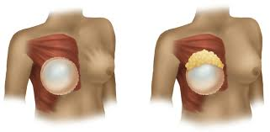
4. Fat Graft for size adjustment. We typically ask patients to wait approximately 3-6 months to allow adequate healing from the previous surgery. As mentioned above, fat can be obtained through a very common procedure called liposuction. The fat is prepared in a specific way to transfer the best fat over the entire reconstruction, in order to increase the size of the breast. When the implant is located under the muscle, the implant can be left in place during the procedure. When the reconstruction is Prepectoral (on top of the muscle), implant removal is typically performed to ensure the proper position of the fat grafts. The procedure can be repeated every 3-6 months, until optimal contouring is achieved.
Creating the breast shape and size are the first priority for most plastic surgeons and, once optimized, completing the reconstruction with a nipple and areola can be very important to some patients. There are some very good options to consider! The nipple and areola reconstruction is performed approximately three (3) months after any revision required to optimize the breast reconstruction.

NIPPLE & AREOLA RECONSTRUCTION
1. 3 Dimensional Tattoos
These tattoos are truly amazing pieces of art! There is only one drawback: insurance won’t pay for a tattoo artist. After breast reconstruction is complete, let the area heal and settle into place for about three months and then consider optimal placement of the nipple and areola. We can then arrange for patients to meet a tattoo artist who is experienced with 3D nipple and areola tattoos.
2. Nipple Reconstruction and Areola Tattoo
We can always reconstruct the nipple and then tattoo the areola around it to give actual projection of the nipple itself. We can then tattoo the correct color for the areola a few months later. This can be done either with a medical tattoo or by a tattoo artist.
3. Nipple Reconstruction with Areola Graft
If your breast-cancer surgeon confirms that it is safe, harvesting your own areola and nippple at the time of mastectomy and immediately grafting them onto the reconstructed breast is also an option. This areola grafting technique is occasionally required for larger-breasted patients when the nipple position on the breast is too low.
4. Nipple Reconstruction and Skin Graft for Areola Reconstruction
After breast reconstruction is complete, a nipple and skin graft is an option for nipple and areola reconstruction. This does not require a tattoo, but it does require time to heal.
The nipple is reconstructed from skin in the area. That areola is a skin graft that is taken from a good color-match skin site.

FREQUENTLY ASKED QUESTIONS ABOUT SURGERY AND BREAST RECONSTRUCTION

- HOW LONG DOES IT TAKE THE BODY TO HEAL AFTER SURGERY?
The body takes six (6) weeks to heal most wounds.
- HOW LONG WILL I BE OUT OF WORK?
This depends on what kind of work you do. If you sit at a desk, you may be able to go to work within 2-4 weeks. If you can work from home, you will likely be able to sit at a computer within a few days, at least for a few hours at a time. If your work is more hands-on, or if the environment of your work space has unusual hazards, you may need to take 6-12 weeks off.
- DOES MY INSURANCE COVER BREAST RECONSTRUCTION?
Yes, it is a Federal law that insurance companies must cover breast reconstruction. Your particular plan’s policies regarding copays and deductibles determines what your out of pocket costs will be. It’s usually quite reasonable.
- HOW ABOUT ANY SURGERY TO AN UNAFFECTED BREAST TO CREATE SYMMETRY?
Yes, those same Federal laws require coverage for procedures to an unaffected breast, in order to create symmetry to the reconstruction, should only a one-sided mastectomy be required.
- HOW MUCH PAIN WILL I BE IN?
Surprisingly, with current techniques, the pain associated with most mastectomies and reconstructions can be managed with oral medications that are prescribed by the surgeon. Some patients, particularly one-sided mastectomy and reconstruction, can go home the same day.
- WHEN CAN I START EXERCISING?
Most procedures require a break from exercising for 4-6 weeks. We ask most patients to avoid lifting heavy items over 5-10 lbs or elevating their heart rate purposely for exercise for 2 weeks after surgery. After two weeks, use common sense and talk over specific questions with your surgeon.
- WHAT CAN I DO TO PREPARE FOR SURGERY?
If you smoke, stop smoking 4-6 weeks prior to surgery to optimize the circulation to your surgical sites. We encourage smoking cessation forever after surgery. However, if that is not possible, the effects of smoking after 6 weeks of healing have less impact on the reconstruction.
- WHAT ARE THE COMPLICATIONS?
Thankfully, when working with an experienced team, the complications are very few. Bleeding, fluid collections around the reconstruction, skin breakdown and infection requiring antibiotics or (rarely) removal of the implant to allow the infection to clear, are always potential complications; however; the risks are quite low.
- HOW LONG WILL MY BREAST IMPLANTS LAST?
The warranty for cosmetic patients is 20 years for most current-generation silicone breast implants. The rupture rate is still being evaluated to give more exact statistics, but a good rule of thumb is to be mentally prepared for one exchange in a lifetime.
- WHAT IS THE LONG-TERM MAINTENANCE FOR BREAST IMPLANTS?
Monitoring of permanent silicone breast implants is recommended to start at year 3 and to be performed every 2 years to follow. Imaging modalities like MRI, ultrasound or CT have been used in the past, with MRI being the gold standard and ultrasound being the easiest.

In conclusion, the general topics that we covered in this book are the following:
- A brief history of breast reconstruction.
- Why breast reconstruction is important—it’s so much more than a simple cosmetic consideration.
- Options for using tissue from your own body for breast reconstruction.
- An organized system for understanding implant-based reconstruction with the overlap of reconstruction that uses your own tissue.
- How to improve completed breast reconstruction for optimal results.
- Nipple and areola reconstruction options.
- Commonly asked questions about breast reconstruction and surgery in general.

I sincerely hope that reading this eBook makes you feel as though you have had a consultation with me. The format was written in a manner similar to how I discuss breast reconstruction with my patients in the office. Since my background, training and interests center around aesthetic plastic surgery, my goal in breast reconstruction is to create an outcome that not only makes the patient feel not only whole again, but also beautiful. Most patients walk out after completing breast reconstruction with more aesthetically ideal breasts than they walk in with-- and the best part is that they know it and they love the outcome! Supporting that approach to breast reconstruction over the years is the fact that perhaps the most emotional visit I have with patients in my office is the visit where I tell them that I really don’t need to see them for 1-2 years. There are usually hugs involved, misty eyes and occasionally a tear—the journey of breast cancer is usually behind you and the road ahead is hopefully looking good!

All the best,
Steve Szczerba, MD

